Big Data Assignment 2: Benchmarking

2. Database initialization and loading:

a. time mysql -uroot -p -D flight --local-infile=1 < air_ddl.sql

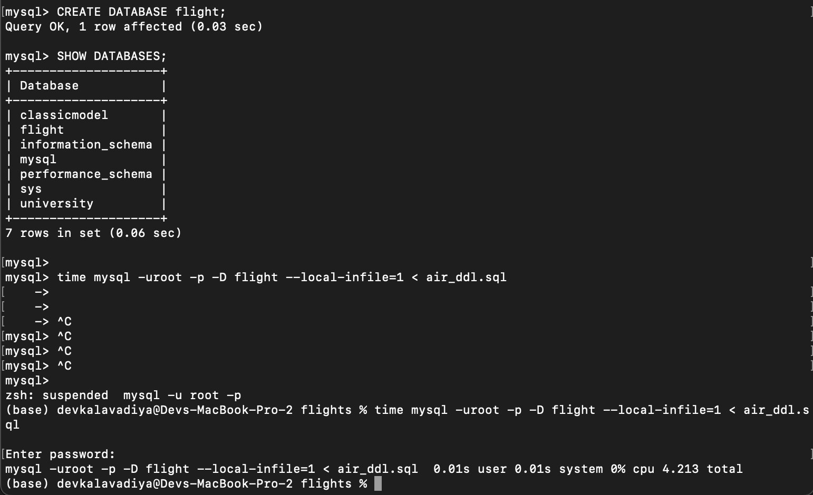

b. time mclient -u monetdb -d flight < air_ddl.sql

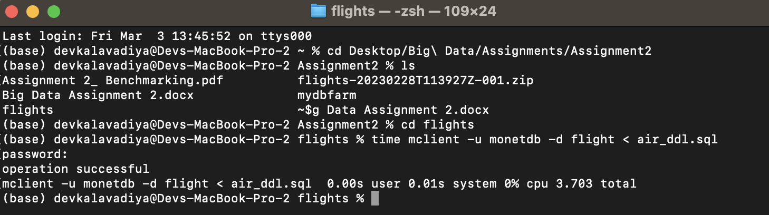

B. Data Loading  
a. time mysql -uroot -p -D flight --local-infile=1 < load_mysql.sql

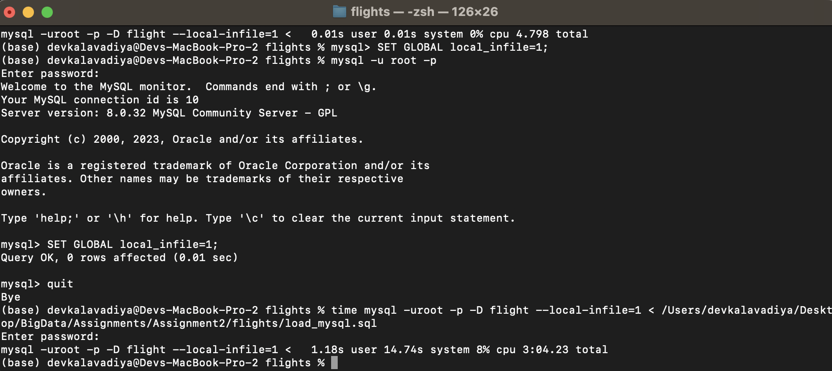

b. time mclient -u monetdb -d flight < load_monetdb.sql

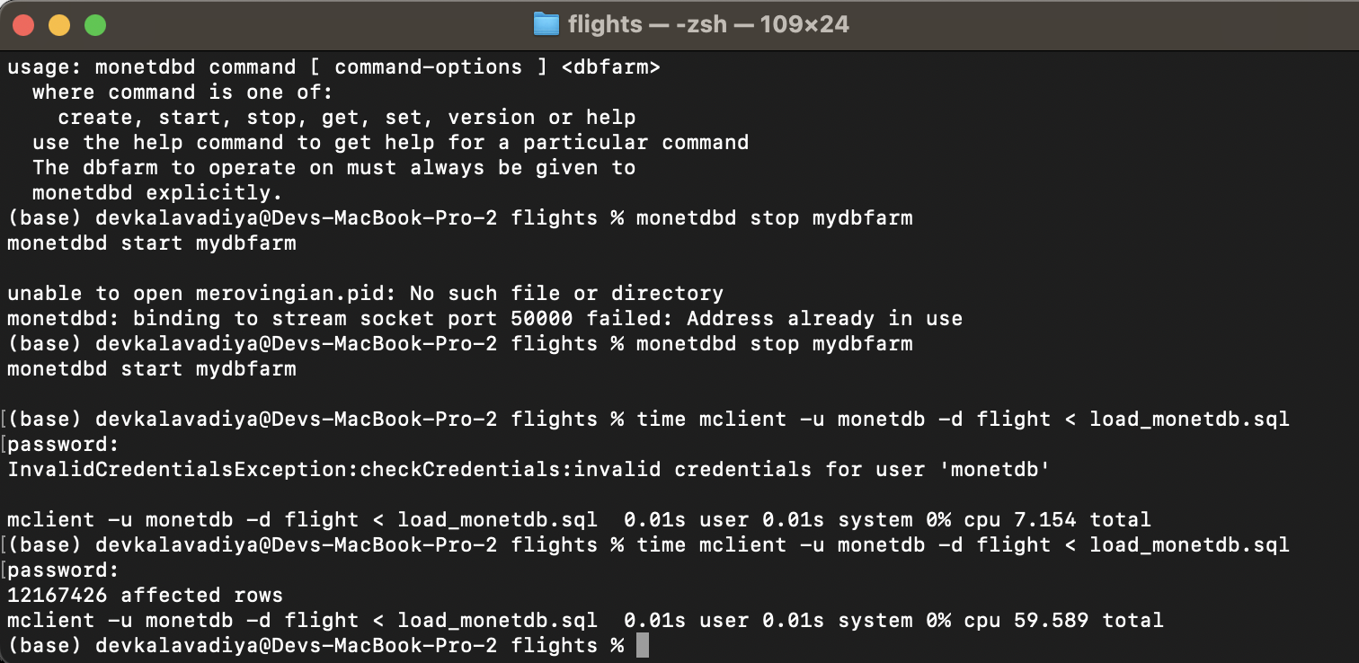

* Get the table status in both system: **(0.5 point)**

- MySQL

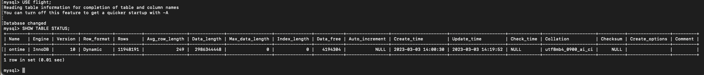

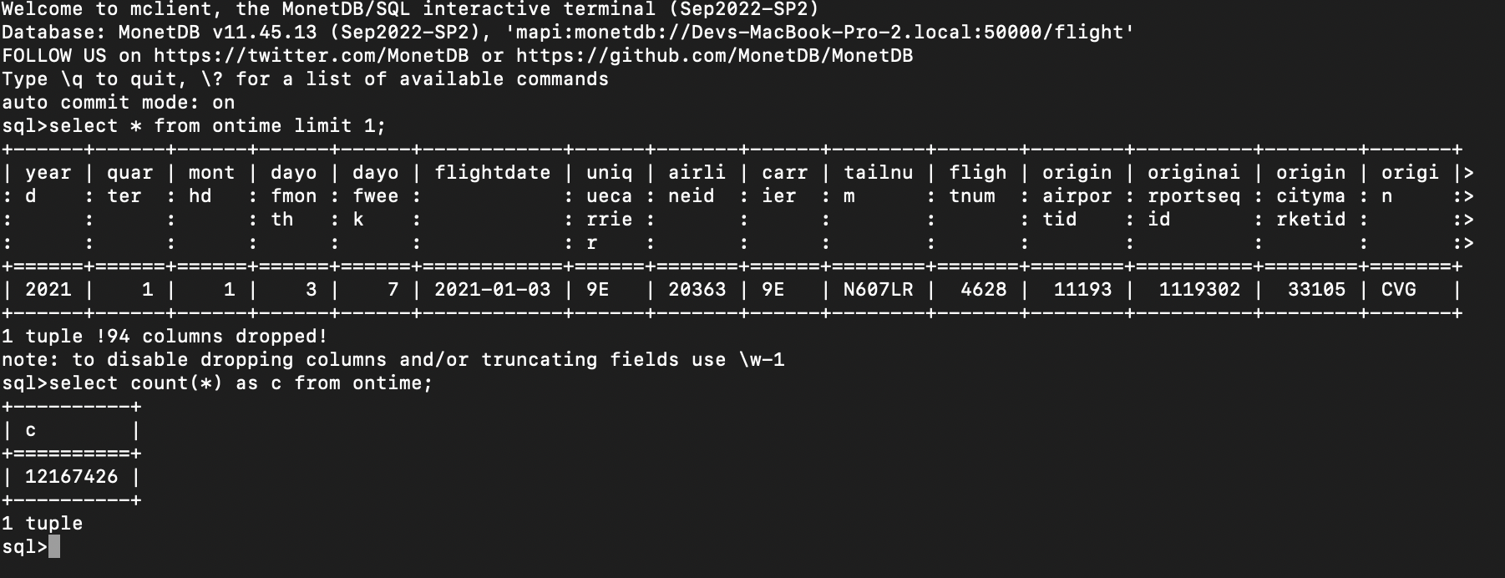- MonetDB

Query Execution Screenshots

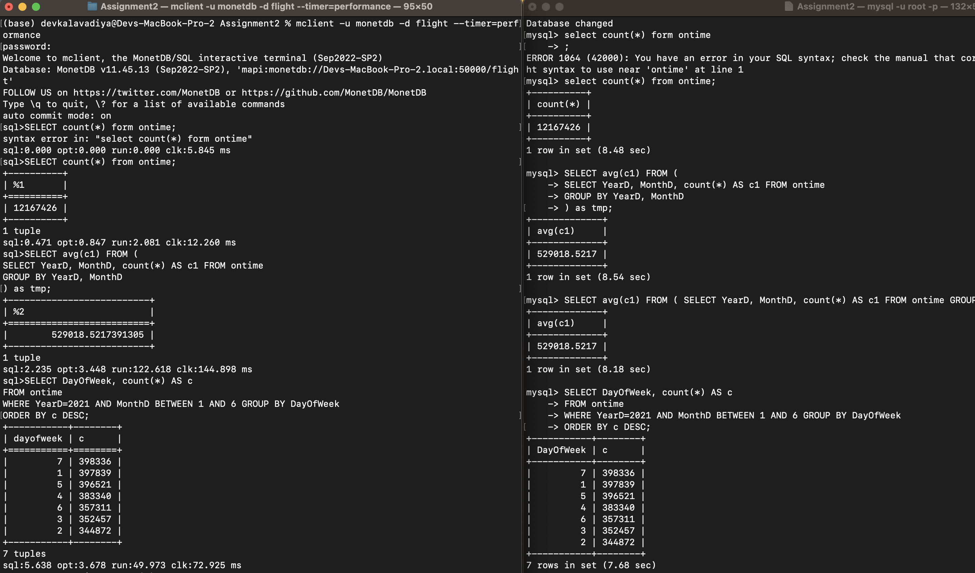

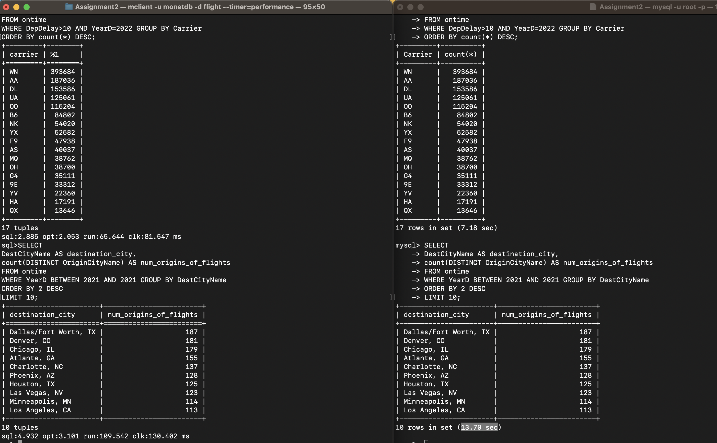

|  |  |  |
| --- | --- | --- |
| Query No | MySQL Execution Time | MonetDB Execution Time |
| 1 | 8480 ms | 2.081 ms |
| 2 | 8540 ms | 122.618 ms |
| 3 | 7680 ms | 49.973 ms |
| 4 | 7180 ms | 65.644 ms |
| 5 | 13700 ms | 109.542 ms |

Based on the results of the queries, it is clear that MonetDB outperforms MySQL in terms of execution time for all 5 queries. The difference in performance is particularly noticeable in queries 1, 2 and 5, where MonetDB's execution time is significantly lower than MySQL's.

The difference in performance can be attributed to the different data storage models used by the two systems. MonetDB uses a column-oriented storage model, which is optimized for analytical queries that typically involve aggregations and scans over large data sets. However, MySQL uses a row-oriented storage model, which is optimized for transactional queries that typically involve retrieving a small number of rows from a table.

Overall, the performance difference between MonetDB and MySQL highlights the importance of selecting a database system that is optimized for the specific use case. If the focus is on analytical queries that involve aggregations and scans over large data sets, a column-oriented database system like MonetDB may be a better choice. However, if the focus is on transactional queries that involve retrieving a small number of rows from a table, a row-oriented database system like MySQL may be a better choice.

Based on the results, query 5 has the largest difference in execution time between MySQL and MonetDB. To improve the performance of MySQL for this query, here are some possible strategies:

* Index optimization: By ensuring that the relevant columns used in the query are properly indexed. In particular, the columns YearD, DestCityName, and OriginCityName could benefit from indexing.

CREATE INDEX idx_YearD ON ontime (YearD);

* Query optimization: Review the query and look for ways to simplify or optimize it. For example, instead of using BETWEEN 2021 AND 2021 in the WHERE clause, it could be simplified to YearD = 2021.

**Part 2**

Creating the new database

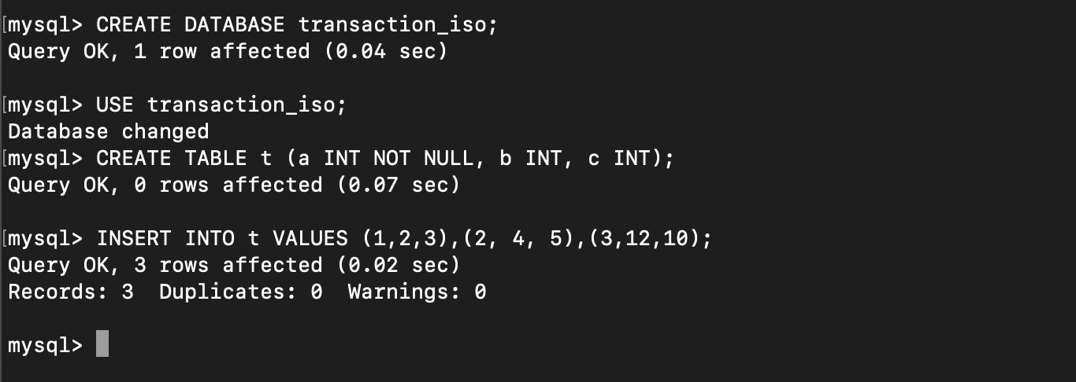

*● Phantom read.*

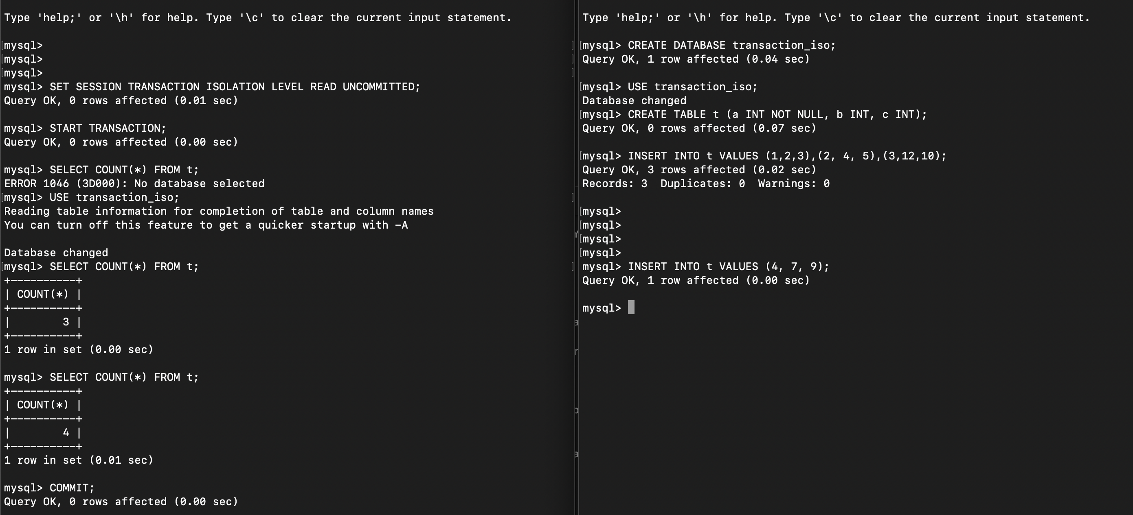

Count is different after inserting in a separate SQL client (on the right) even though the left terminal had a START TRANSACTION, and the commit was made after.

In this example we can see that Terminal 1 starts a transaction and reads the data from the t table where the count is 3. While Terminal 1's transaction is still open, Terminal 2 inserts a new row into the t table, which causes the count to increment to 4. Terminal 1 then makes another read to count the values in t, where it finds the count to be 4 instead of 3, resulting in a phantom read concurrency problem.

*● Unrepeatable read.*

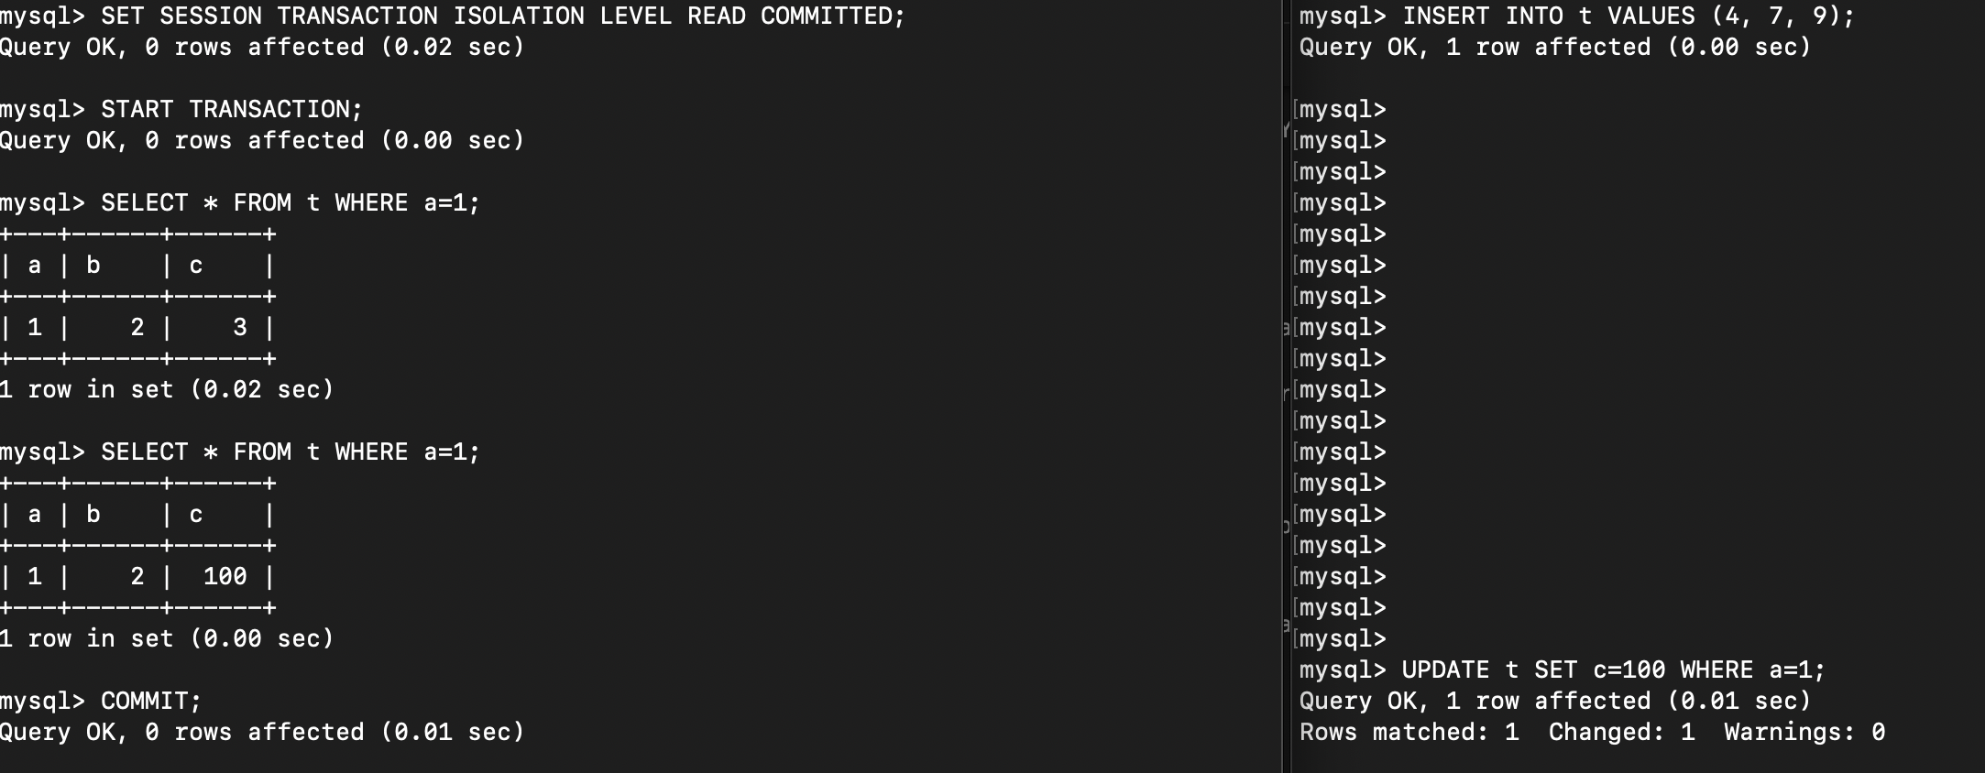

In this scenario, the unrepeatable read problem is simulated by allowing a transaction to read committed data that has been modified by another transaction, resulting in the transaction seeing different data in subsequent reads. As seen in the image, there are 2 Terminals and Terminal 1 starts first as it reads the tuple where a=1. At this point, Terminal 2 updates the value of c to 100 in that same tuple. Hence when Terminal 1 comes to make a second read for the same tuple, it gets 100, resulting in a unrepeatable read concurrency problem.

*● Dirty read.*

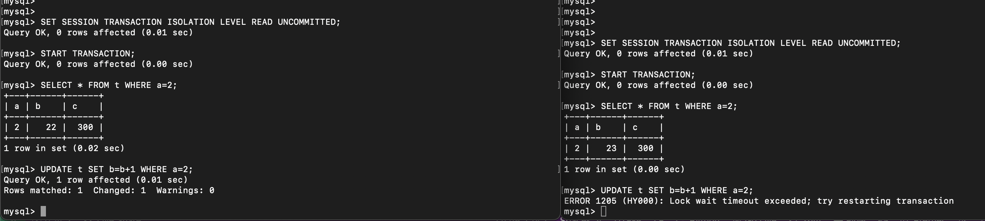

This is an example of a dirty read because Terminal 2 reads uncommitted data that was modified by an uncommitted transaction in Terminal 1.

In Terminal 1, the transaction reads the row where a=2, and then updates the value of b. The update operation has not yet been committed, so the value of b has not yet been changed in the database.

In Terminal 2, the transaction also reads the row where a=2, and since it is set to READ UNCOMMITTED isolation level, it reads the uncommitted data modified by Terminal 1, which is why it sees the value of b as 23 instead of 22.

However, when Terminal 2 tries to update the same row, it encounters a lock wait timeout, because the row has been locked by the uncommitted transaction in Terminal 1. This means that Terminal 2's transaction cannot proceed until Terminal 1's transaction is either committed or rolled back. If Terminal 1 rolls back its transaction, the update in Terminal 2 will never be committed, and Terminal 2 will have read uncommitted data that was never committed.

*● Lost update.*

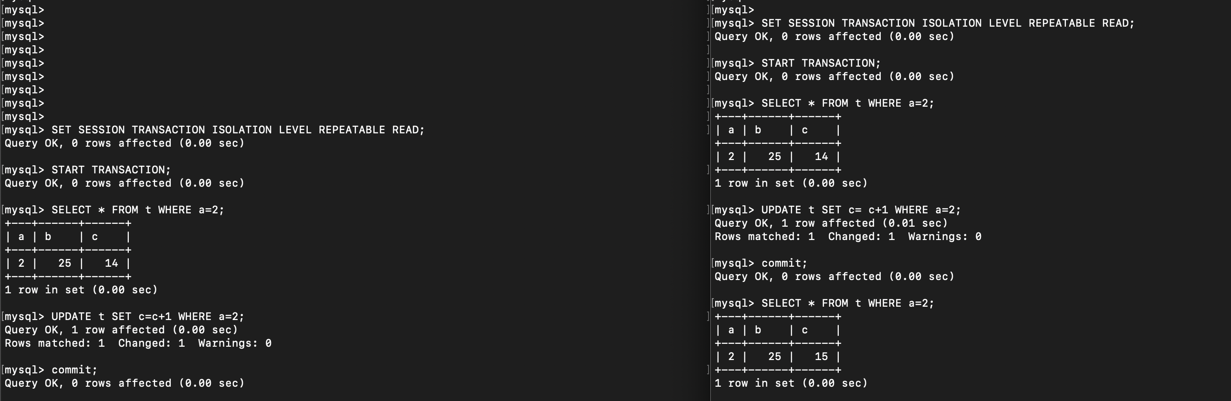

14 + 1 + 1 = 15?

This is an instance of a lost update. In this scenario, both Terminal 1 and Terminal 2 start a transaction and update the same row and increment c by 1. Terminal 1 adds 1 to 14, commits the transaction. After that, Terminal 2 increments the same value by adding 1 and commits the transaction. Since the second update overwrote the value set by the first update, the changes made by Terminal 1 are lost. Thus, the final value of c is 15 instead of 16.

Solution To Lost Update - Serializable

